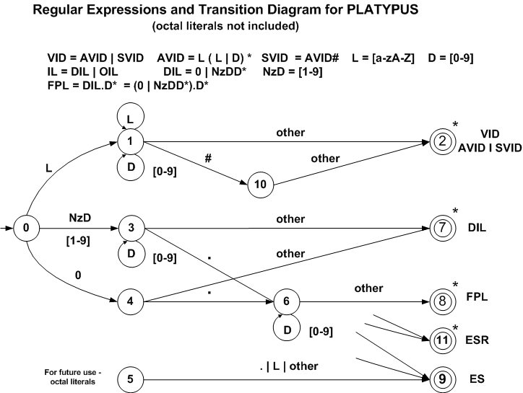

Transition Table
Current  State |  | INPUT SYMBOL |  |  |  |  |  |  | State Type  (Not Accepting or Accepting State)
Current  State | [a-zA-z] |  | 0 | [8-9] | [1-7] | . | # | other | State Type  (Not Accepting or Accepting State)
0 | 1 |  | 4 | 3 | 3 | IS | IS | IS | Not Accepting - NOAS
1 | 1 |  | 1 | 1 | 1 | 2 | 10 | 2 | Not Accepting - NOAS
2 | IS |  | IS | IS | IS | IS | IS | IS | VID - Accept With Retract - ASWR
3 | ES |  | 3 | 3 | 3 | 6 | 7 | 7 | Not Accepting - NOAS
4 | ES |  | ES | ES | 5 | 6 | 7 | 7 | Not Accepting - NOAS
5 | ES |  | 5 | ES | 5 | ES | ES | 9 | Not Accepting - NOAS
6 | 8 |  | 6 | 6 | 6 | 8 | 8 | 8 | Not Accepting - NOAS
7 | IS |  | IS | IS | IS | IS | IS | IS | DIL - Accept With Retract - ASWR
8 | IS |  | IS | IS | IS | IS | IS | IS | FPL - Accept With Retract - ASWR
9 | IS |  | IS | IS | IS | IS | IS | IS | OIL - Accept With Retract - ASWR
10 | ES |  | ES | ES | ES | ES | ES | 2 | Not Accepting – NOAS
11 | IS |  | IS | IS | IS | IS | IS | IS | ES – Accept No Retract - AWNR

IS – Illegal State ES – Error State E/A – Error or Accepting State

